**WEEK-4**

**SPRING-REST-HANDSON**

**Hands on 1: Create a Spring Web Project using Maven**

**MY CODE:**

**Pom.xml**

<project xmlns="http://maven.apache.org/POM/4.0.0"

xmlns:xsi="http://www.w3.org/2001/XMLSchema-instance"

xsi:schemaLocation="http://maven.apache.org/POM/4.0.0

http://maven.apache.org/xsd/maven-4.0.0.xsd">

<modelVersion>4.0.0</modelVersion>

<groupId>com.cognizant</groupId>

<artifactId>spring-learn</artifactId>

<version>0.0.1-SNAPSHOT</version>

<packaging>jar</packaging>

<name>spring-learn</name>

<parent>

<groupId>org.springframework.boot</groupId>

<artifactId>spring-boot-starter-parent</artifactId>

<version>3.2.4</version>

<relativePath/> <!-- lookup parent from repository -->

</parent>

<properties>

<java.version>17</java.version>

</properties>

<dependencies>

<!-- Spring Web -->

<dependency>

<groupId>org.springframework.boot</groupId>

<artifactId>spring-boot-starter-web</artifactId>

</dependency>

<!-- DevTools -->

<dependency>

<groupId>org.springframework.boot</groupId>

<artifactId>spring-boot-devtools</artifactId>

<scope>runtime</scope>

</dependency>

<!-- Test -->

<dependency>

<groupId>org.springframework.boot</groupId>

<artifactId>spring-boot-starter-test</artifactId>

<scope>test</scope>

</dependency>

</dependencies>

<build>

<plugins>

<plugin>

<groupId>org.springframework.boot</groupId>

<artifactId>spring-boot-maven-plugin</artifactId>

</plugin>

</plugins>

</build>

</project>

**SpringLearnApplication.java**

package com.cognizant.springlearn;

import org.springframework.boot.SpringApplication;

import org.springframework.boot.autoconfigure.SpringBootApplication;

@SpringBootApplication

public class SpringLearnApplication {

public static void main(String[] args) {

SpringApplication.run(SpringLearnApplication.class, args);

System.out.println("SpringLearnApplication started successfully...");

}

}

**HelloController.java**

package com.cognizant.springlearn.controller;

import com.cognizant.springlearn.service.HelloService;

import org.springframework.web.bind.annotation.GetMapping;

import org.springframework.web.bind.annotation.RestController;

@RestController

public class HelloController {

private final HelloService helloService;

public HelloController(HelloService helloService) {

this.helloService = helloService;

}

@GetMapping("/hello")

public String sayHello() {

return helloService.getGreeting();

}

}

## HelloService.java

## package com.cognizant.springlearn.service;

## import org.springframework.stereotype.Service;

## @Service

## public class HelloService {

## public String getGreeting() {

## return "Hello from Spring Boot! 🌼";

## }

## }

**application.properties**

# Application Config

server.port=8080

spring.application.name=spring-learn

# Logging

logging.level.root=INFO

**OUTPUT:**

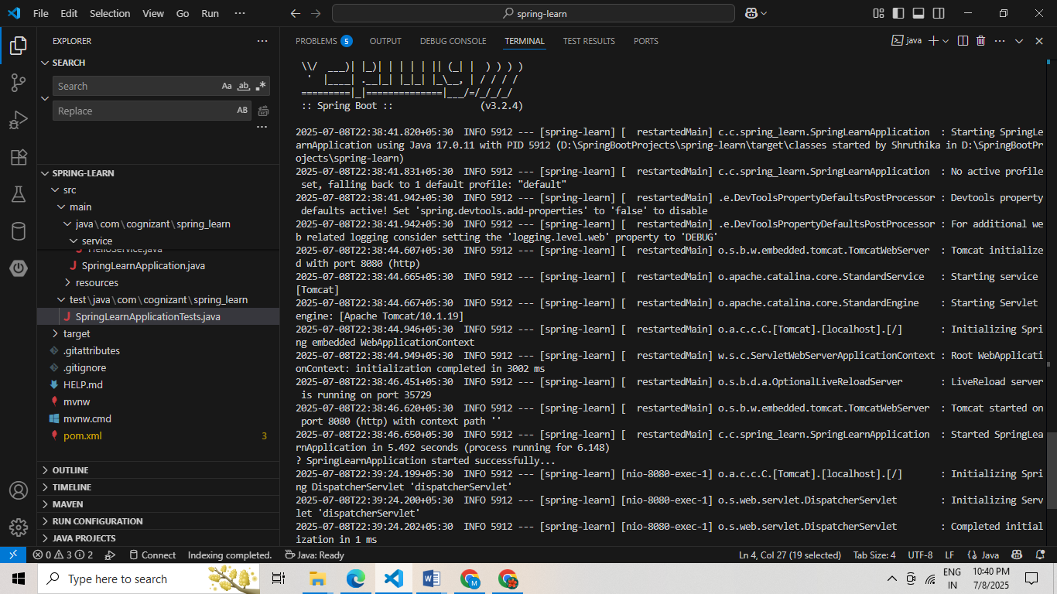

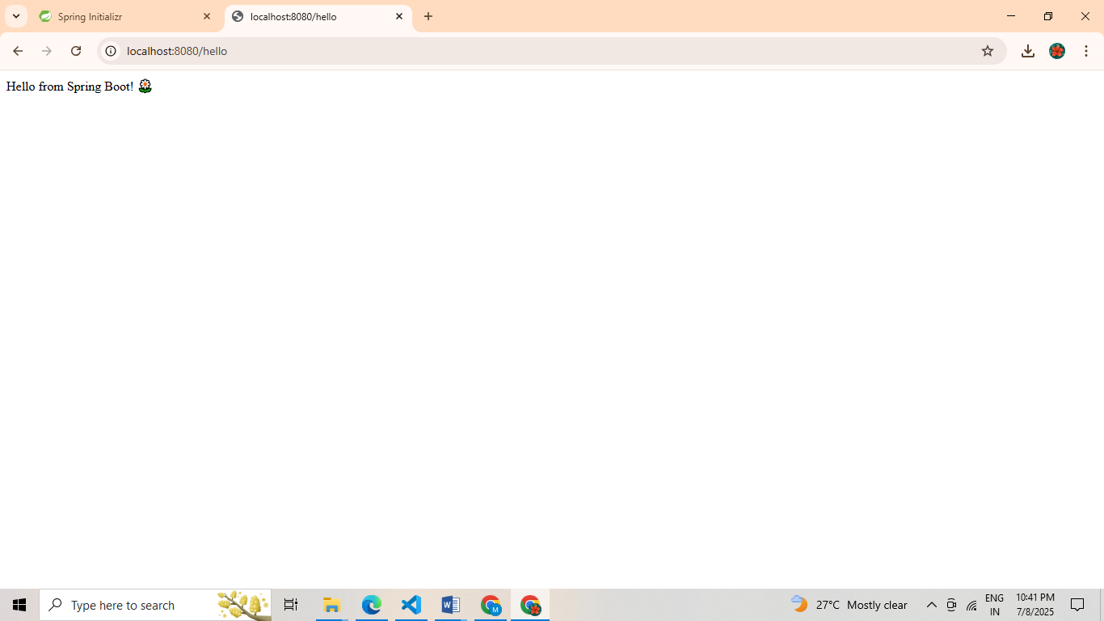

**Hands on 4 : Spring Core – Load Country from Spring Configuration XML**

**MY CODE:**

Country.java

package com.cognizant.spring_learn;

public class Country {

private String code;

private String name;

public Country() {

System.out.println("Inside Country Constructor.");

}

public String getCode() {

System.out.println("Getting code");

return code;

}

public void setCode(String code) {

System.out.println("Setting code: " + code);

this.code = code;

}

public String getName() {

System.out.println("Getting name");

return name;

}

public void setName(String name) {

System.out.println("Setting name: " + name);

this.name = name;

}

@Override

public String toString() {

return "Country [code=" + code + ", name=" + name + "]";

}

}

**SpringLearnApplication.java**

package com.cognizant.spring_learn;

import org.slf4j.Logger;

import org.slf4j.LoggerFactory;

import org.springframework.context.ApplicationContext;

import org.springframework.context.support.ClassPathXmlApplicationContext;

public class SpringLearnApplication {

private static final Logger LOGGER = LoggerFactory.getLogger(SpringLearnApplication.class);

public static void main(String[] args) {

displayCountry();

}

public static void displayCountry() {

ApplicationContext context = new ClassPathXmlApplicationContext("country.xml");

Country country = context.getBean("country", Country.class);

LOGGER.debug("Country : {}", country.toString());

}

}

**Country.xml**

package com.cognizant.spring_learn;

import org.slf4j.Logger;

import org.slf4j.LoggerFactory;

import org.springframework.context.ApplicationContext;

import org.springframework.context.support.ClassPathXmlApplicationContext;

public class SpringLearnApplication {

private static final Logger LOGGER = LoggerFactory.getLogger(SpringLearnApplication.class);

public static void main(String[] args) {

displayCountry();

}

public static void displayCountry() {

ApplicationContext context = new ClassPathXmlApplicationContext("country.xml");

Country country = context.getBean("country", Country.class);

LOGGER.debug("Country : {}", country.toString());

}

}

**OUTPUT:**

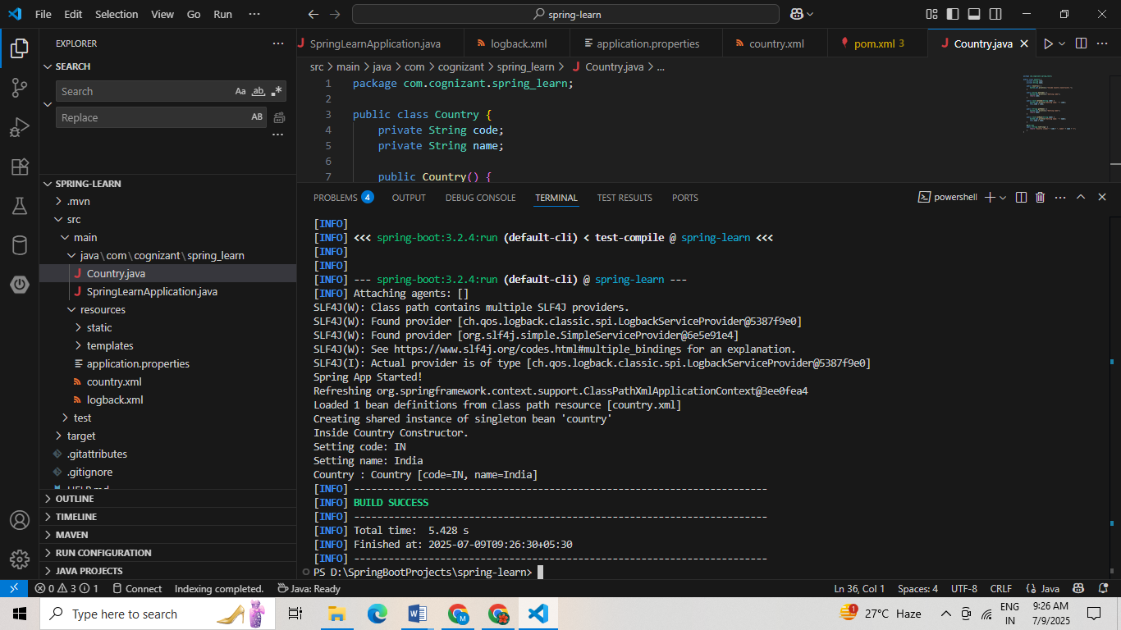

**Hello World RESTful Web Service**

**MY CODE:**

**SpringLearnApplication.java**

package com.cognizant.spring_learn;

import org.springframework.boot.SpringApplication;

import org.springframework.boot.autoconfigure.SpringBootApplication;

@SpringBootApplication

public class SpringLearnApplication {

public static void main(String[] args) {

SpringApplication.run(SpringLearnApplication.class, args);

}

}

**HelloController.java**

package com.cognizant.spring_learn.controller;

import org.slf4j.Logger;

import org.slf4j.LoggerFactory;

import org.springframework.web.bind.annotation.GetMapping;

import org.springframework.web.bind.annotation.RestController;

@RestController

public class HelloController {

private static final Logger LOGGER = LoggerFactory.getLogger(HelloController.class);

@GetMapping("/hello")

public String sayHello() {

LOGGER.info("START: sayHello()");

LOGGER.info("END: sayHello()");

return "Hello World!!";

}

}

**Application properties**

server.port=8083

**OUTPUT:**

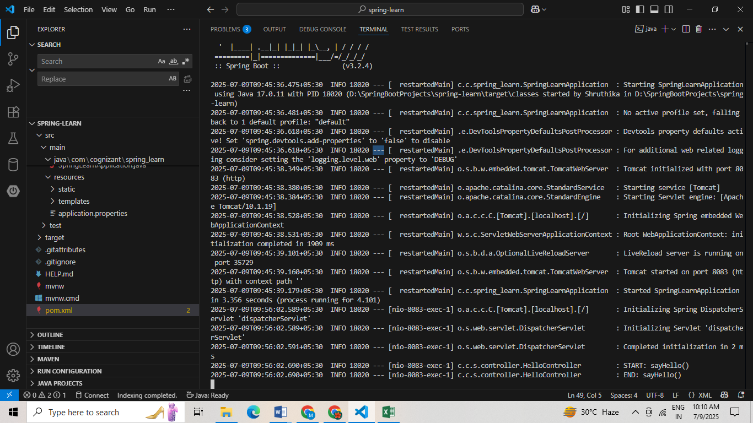

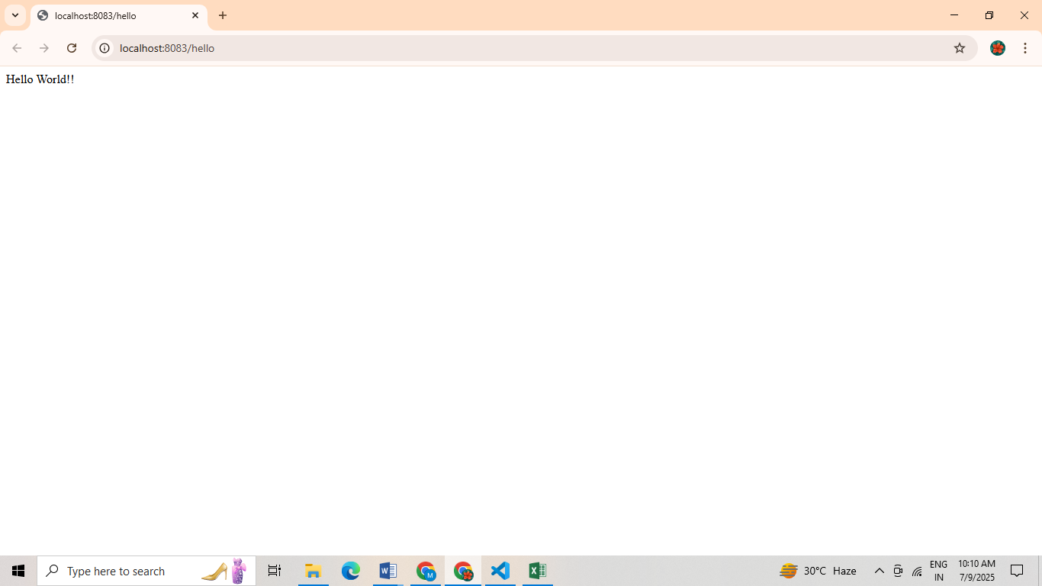

**REST - Country Web Service**

**MY CODE:**

Country.java

package com.cognizant.spring_learn;

public class Country {

private String code;

private String name;

public Country() {

System.out.println("Inside Country Constructor.");

}

public String getCode() {

System.out.println("Getting code: " + code);

return code;

}

public void setCode(String code) {

System.out.println("Setting code: " + code);

this.code = code;

}

public String getName() {

System.out.println("Getting name: " + name);

return name;

}

public void setName(String name) {

System.out.println("Setting name: " + name);

this.name = name;

}

@Override

public String toString() {

return "Country [code=" + code + ", name=" + name + "]";

}

}

**CountryController.java**

package com.cognizant.spring_learn.controller;

import com.cognizant.spring_learn.Country;

import org.slf4j.Logger;

import org.slf4j.LoggerFactory;

import org.springframework.context.ApplicationContext;

import org.springframework.context.support.ClassPathXmlApplicationContext;

import org.springframework.web.bind.annotation.RequestMapping;

import org.springframework.web.bind.annotation.RestController;

@RestController

public class CountryController {

private static final Logger LOGGER = LoggerFactory.getLogger(CountryController.class);

@RequestMapping("/country")

public Country getCountryIndia() {

LOGGER.info("START - getCountryIndia()");

ApplicationContext context = new ClassPathXmlApplicationContext("country.xml");

Country country = context.getBean("country", Country.class);

LOGGER.info("END - getCountryIndia()");

return country;

}

}

**country.xml**

<beans xmlns="http://www.springframework.org/schema/beans"

xmlns:xsi="http://www.w3.org/2001/XMLSchema-instance"

xsi:schemaLocation="http://www.springframework.org/schema/beans

http://www.springframework.org/schema/beans/spring-beans.xsd">

<bean id="country" class="com.cognizant.spring_learn.Country">

<property name="code" value="IN"/>

<property name="name" value="India"/>

</bean>

</beans>

**OUTPUT:**

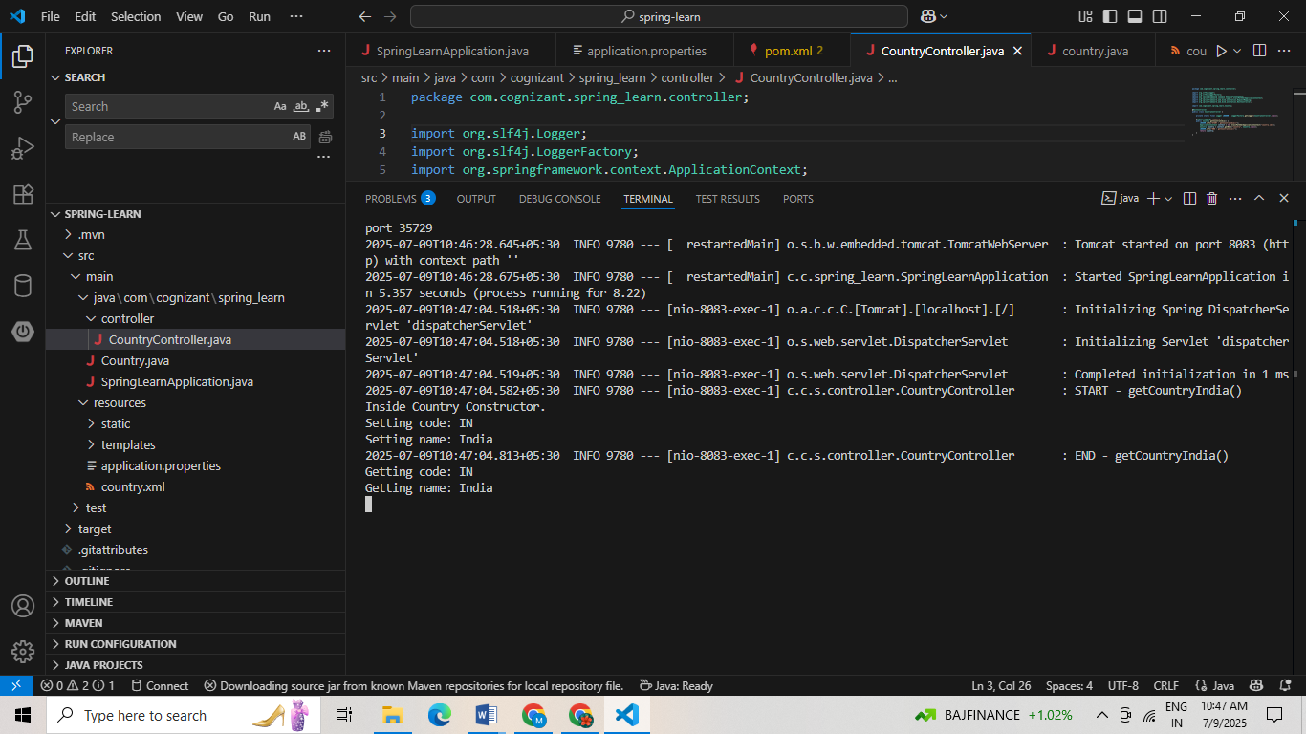

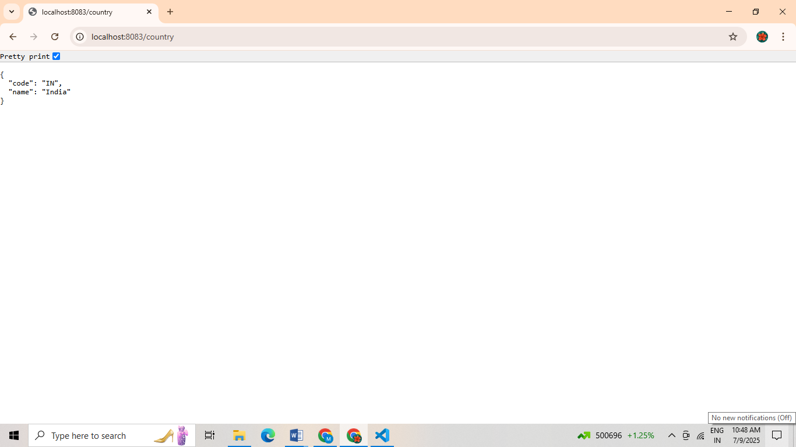

**REST - Get country based on country code**

**MY CODE:**

**Country.java**

package com.cognizant.spring_learn;

public class Country {

private String code;

private String name;

public Country() {

System.out.println("Inside Country Constructor.");

}

public String getCode() {

return code;

}

public void setCode(String code) {

System.out.println("Setting code: " + code);

this.code = code;

}

public String getName() {

return name;

}

public void setName(String name) {

System.out.println("Setting name: " + name);

this.name = name;

}

@Override

public String toString() {

return "Country [code=" + code + ", name=" + name + "]";

}

}

**CountryService.java**

package com.cognizant.spring_learn.service;

import com.cognizant.spring_learn.Country;

import org.springframework.context.ApplicationContext;

import org.springframework.context.support.ClassPathXmlApplicationContext;

import org.springframework.stereotype.Service;

import java.util.List;

@Service

public class CountryService {

public Country getCountry(String code) {

ApplicationContext context = new ClassPathXmlApplicationContext("country.xml");

List<Country> countryList = (List<Country>) context.getBean("countryList");

return countryList.stream()

.filter(country -> country.getCode().equalsIgnoreCase(code))

.findFirst()

.orElse(null);

}

}

**CountryController.java**

package com.cognizant.spring_learn.controller;

import com.cognizant.spring_learn.Country;

import com.cognizant.spring_learn.service.CountryService;

import org.slf4j.Logger;

import org.slf4j.LoggerFactory;

import org.springframework.beans.factory.annotation.Autowired;

import org.springframework.web.bind.annotation.*;

@RestController

public class CountryController {

private static final Logger LOGGER = LoggerFactory.getLogger(CountryController.class);

@Autowired

private CountryService countryService;

@GetMapping("/country/{code}")

public Country getCountry(@PathVariable String code) {

LOGGER.info("START - getCountry()");

Country country = countryService.getCountry(code);

LOGGER.info("END - getCountry()");

return country;

}

}

**country.xml**

<?xml version="1.0" encoding="UTF-8"?>

<beans xmlns="http://www.springframework.org/schema/beans"

xmlns:util="http://www.springframework.org/schema/util"

xmlns:xsi="http://www.w3.org/2001/XMLSchema-instance"

xsi:schemaLocation="

http://www.springframework.org/schema/beans

https://www.springframework.org/schema/beans/spring-beans.xsd

http://www.springframework.org/schema/util

https://www.springframework.org/schema/util/spring-util.xsd">

<bean id="country" class="com.cognizant.spring_learn.Country">

<property name="code" value="IN"/>

<property name="name" value="India"/>

</bean>

<util:list id="countryList" value-type="com.cognizant.spring_learn.Country">

<bean class="com.cognizant.spring_learn.Country">

<property name="code" value="US"/>

<property name="name" value="United States"/>

</bean>

<bean class="com.cognizant.spring_learn.Country">

<property name="code" value="DE"/>

<property name="name" value="Germany"/>

</bean>

<bean class="com.cognizant.spring_learn.Country">

<property name="code" value="IN"/>

<property name="name" value="India"/>

</bean>

<bean class="com.cognizant.spring_learn.Country">

<property name="code" value="JP"/>

<property name="name" value="Japan"/>

</bean>

</util:list>

</beans>

**OUTPUT:**

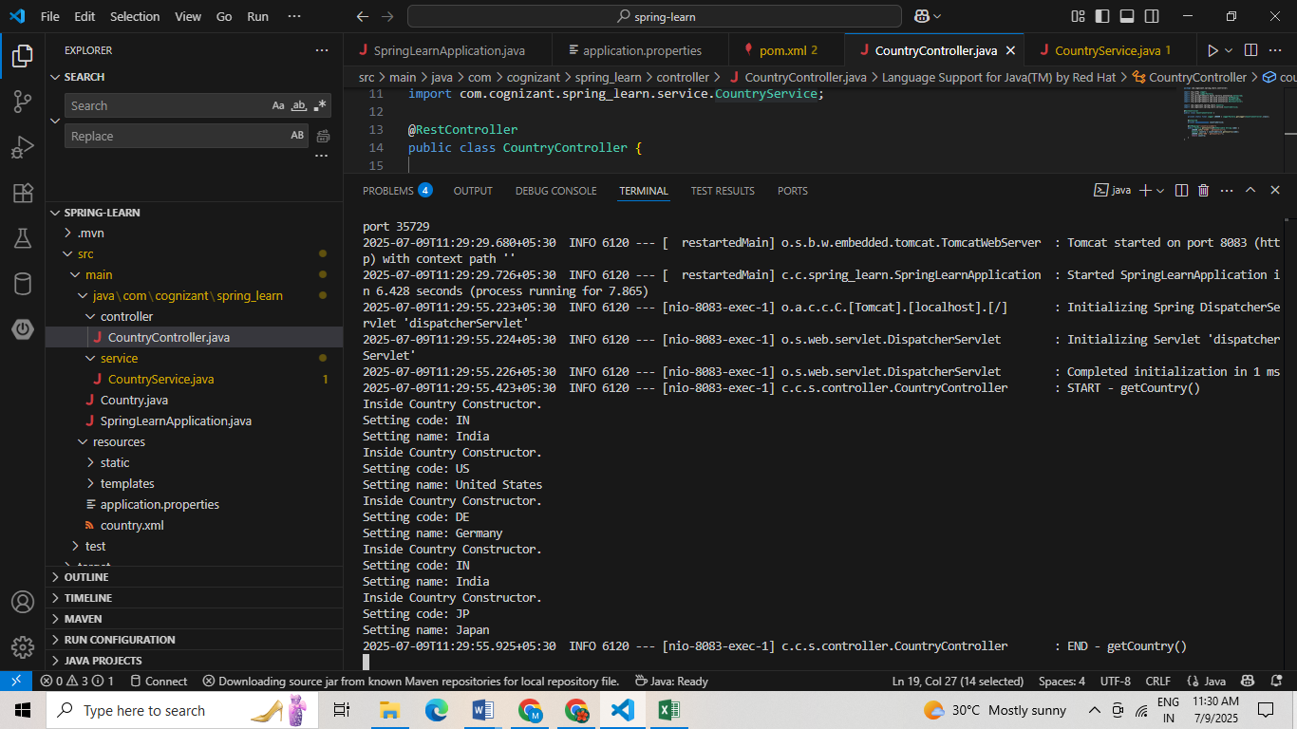

**JWT- HANDSON**

**Create authentication service that returns JWT**

**MY CODE:**

**JwtUtil.java**

@Component

public class JwtUtil {

private String secretKey = "mysecretkey";

public String generateToken(String username) {

return Jwts.builder()

.setSubject(username)

.setIssuedAt(new Date(System.currentTimeMillis()))

.setExpiration(new Date(System.currentTimeMillis() + 1000 * 60 * 60)) // 1 hour

.signWith(SignatureAlgorithm.HS256, secretKey.getBytes())

.compact();

}

}

**SecurityConfig.java**

package com.cognizant.spring_learn.config;

import org.springframework.context.annotation.Bean;

import org.springframework.context.annotation.Configuration;

import org.springframework.security.config.Customizer;

import org.springframework.security.config.annotation.web.builders.HttpSecurity;

import org.springframework.security.web.SecurityFilterChain;

import org.springframework.security.core.userdetails.User;

import org.springframework.security.core.userdetails.UserDetails;

import org.springframework.security.core.userdetails.UserDetailsService;

import org.springframework.security.provisioning.InMemoryUserDetailsManager;

import org.springframework.security.crypto.bcrypt.BCryptPasswordEncoder;

import org.springframework.security.crypto.password.PasswordEncoder;

@Configuration

public class SecurityConfig {

@Bean

public SecurityFilterChain securityFilterChain(HttpSecurity http) throws Exception {

http.csrf(csrf -> csrf.disable())

.authorizeHttpRequests(auth -> auth

.requestMatchers("/authenticate").permitAll()

.anyRequest().authenticated()

)

.httpBasic(Customizer.withDefaults());

return http.build();

}

@Bean

public UserDetailsService userDetailsService() {

UserDetails user = User.withUsername("user")

.password(passwordEncoder().encode("pwd"))

.roles("USER")

.build();

return new InMemoryUserDetailsManager(user);

}

@Bean

public PasswordEncoder passwordEncoder() {

return new BCryptPasswordEncoder();

}

}

**AuthenticationController.java**

package com.cognizant.spring_learn.controller;

import org.springframework.beans.factory.annotation.Autowired;

import org.springframework.security.core.Authentication;

import org.springframework.web.bind.annotation.GetMapping;

import org.springframework.web.bind.annotation.RestController;

import com.cognizant.spring_learn.util.JwtUtil;

@RestController

public class AuthenticationController {

@Autowired

private JwtUtil;

@GetMapping("/authenticate")

public String authenticate(Authentication authentication) {

String username = authentication.getName();

return jwtUtil.generateToken(username);

}

}

**Pom.xml**

<dependencies>

<!-- Spring Boot Starter Web -->

<dependency>

<groupId>org.springframework.boot</groupId>

<artifactId>spring-boot-starter-web</artifactId>

</dependency>

<!-- Spring Boot Starter Security -->

<dependency>

<groupId>org.springframework.boot</groupId>

<artifactId>spring-boot-starter-security</artifactId>

</dependency>

<!-- JWT (JJWT) -->

<dependency>

<groupId>io.jsonwebtoken</groupId>

<artifactId>jjwt</artifactId>

<version>0.9.1</version>

</dependency>

<!-- JAXB for DatatypeConverter (Java 11+ requirement) -->

<dependency>

<groupId>javax.xml.bind</groupId>

<artifactId>jaxb-api</artifactId>

<version>2.3.1</version>

</dependency> </dependencies>

**OUTPUT:**

